THE BID
(Attachment No. 1)

Public tender subject: Used control system parts VI
Name of the seller: Nuclear and Decommissioning Company, plc.,
Tenderer name (Company or personal): to be filled in by the tenderer
ID / Date of birth: to be filled in by the tenderer
VAT ID: to be filled in by the tenderer (YES or NO)
Bank name, IBAN: to be filled in by the interested party
(for the purposes of returning the financial guarantee)
Contact person: to be filled in by the tenderer (name and surname of contact person)
Contact e-mail: to be filled in by the tenderer
Contact tel. number: to be filled in by the tenderer

Item (Siemens ID) | Amount | Unit price in  EUR without VAT | Total price per item in EUR without VAT
Modul SLLM (6FK5243-8AA) | 30
Total price in EUR without VAT
I declare that I agree with all the conditions of the public tender and accept state in which the subject of the public tender is. I agree with the validity of the above offer until 20.09.2025.

In ................................... date .........................

..............................................................
Name, surname, position, signature
and stamp (if tenderer uses the stamp) statutory representative authorized to act on behalf of the tenderer

Photo Documentation
(Attachment No. 2)

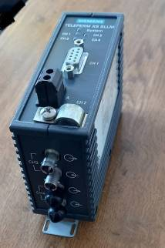 | 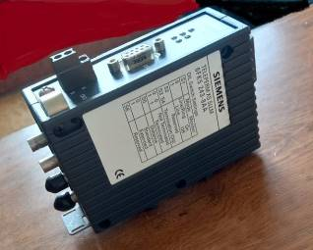
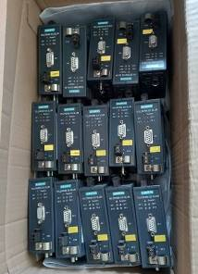 | 